Talking Therapy by Pratyusha Dwivedi

Fred Newman was an American philosopher and psychotherapist who believed in the benefits of therapy. He once said:

*“****Therapy*** *is helpful because and to the extent that it socializes what we mistakenly experience as individualistic and private. It works because of what therapists and clients are doing together. … And what therapists and clients are doing together is creating something new—a new relationship, a new way of speaking, new meanings. This is possible because we are social beings who, in spite of the myth of individualism and inner states of mind, are forever interconnected in the activity of living. Therapy works because it exposes and creates with our relational interconnectivity.* ***It “brings out” and develops what’s most positive about us.****”*

People often like to believe that they are bigger than the problems that they face. They think they are able enough to handle every challenge that comes their way. Sometimes however, the challenges demand more energy and/ or resources than those they have available. They might require talking to someone who will look at the situation objectively and help gain a better perspective; which may not happen when talking to a friend or relative. More importantly, a person may sometimes just want someone to listen to what they have to say.

**Counselling** is a kind of talking therapy that establishes a platform for a person to talk about their problems and feelings in a confidential and non - judgmental environment, regardless of the nature of that problem. Counselors see clients who have developmental or situational concerns that require help with regard to adjustment or remediation. These problems need only short-term involvement till the client reaches a point where he/she is able to handle the problem better. Occasionally, treatment may be extended to encompass disorders like bipolarity or OCD.

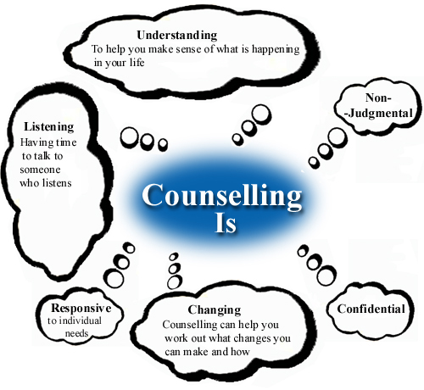

Counsellors undergo extensive training that enables them to empathize with the speaker. They are prepared to help one deal with any existing negative thoughts and feelings, prevent the arising of new ones and provide insight into the situation at hand.

Apart from understanding and helping deal with a stressful situation or symptoms of any disorder or illness, the aim of therapy is to help one understand underlying issues and make healthy and appropriate decisions. Therapy attempts to help one get in touch with their emotions better, it facilitates self- knowledge, growth and the optimal development of personal resources. Therapy is a step that can help one live more satisfyingly.

**SEVA**is a non-profit organisation that provides free and confidential counselling services. Well-trained professionals address the needs of people dealing with problems ranging from loneliness and alcoholism to mental breakdown.

Here, we help people rediscover Happiness & Peace.

# References

<http://queensu.ca/hcds/cs/about/why.html>.

<http://www.nationalpsychotherapyday.com/whytherapy.php>.

Lois Holzman, Ph.D. A Conceptual Revolution. <http://www.psychologytoday.com/blog/conceptual-revolution/201311/the-surprising-secret-why-therapy-works>.

<http://www.sevacounselingcentre.org/Home.aspx>

<http://www.ccpa-accp.ca/_documents/NotebookEthics/What%20is%20Counselling%20A%20Search%20for%20a%20Definition.pdf >